New changes

- On the admin panel, we want the section name “Homepage Edits” . From this section we should be able to edit everything available on the home page of each section and the elements like. Headings, buttons, paragraphs, cards data, stats, CTA’s, etc.
- Blog section auto canonical link is getting created without www. Pls Fix that.
- Remove “| Search Modifiers” from all meta titles attaching automatically.
- Auto addition of table of content is not working.
- Image we are uploading getting url’s like “https://res.cloudinary.com/ddgcu8qkl/image/upload/v1779276884/search-modifiers-admin/vcp6giijhxmeae7a1nia.png” which is getting marked as external link on our site. Fix it so that image urls get our domain name.
- Meta keywords are not accepting and reflecting on the pages.
- What is the use of “tags field” available in blogs>publishing>tags. & Where are they getting reflected on the page.
- Posts count not increasing in the category section.
- The case study section is not working entirely. Updations are not reflecting, new case studies are not reflecting.
- The testimonial section is not working entirely. Updations are not reflecting, new testimonials are not reflecting.
- The location section is not working entirely. Updations are not reflecting, new creations are not reflecting. Also, the location permalink structure will be domainname/location/slug Example: https://www.searchmodifiers.com/india/seo-company-india and we want this section to be renamed as “Country Pages”.
- Create a new section on the admin panel name “City Pages” the permalink structure will be domainname/location/slug Example: https://www.searchmodifiers.com/delhi/seo-company-delhi
- Add a new section on the admin panel name “Manage Locations” from where we will manage locations to use in our “Country Pages” & “City Pages” section selected from the dropdown menu. These locations will not be live and available anywhere on the site; these will be available only for the admin panel use.
- Please add demo content on the ”static pages” section, need to know where they are reflecting.
- The “Team” section is not working entirely. Updations are not reflecting, new “team members” are not reflecting.
- The “Career” section is not working entirely. Updates are not reflecting, new “Career” are not reflecting. Apply buttons are not working on page: https://www.searchmodifiers.com/careers
- Redesign the FAQ section again, add fields | Question | Answer | Where to insert [Drop Down options: Page, Blog, Country Pages, City Pages] | Select exact page | At which sequence 1/2/3/4.
- The “Portfolio” section is not working entirely. Updations are not reflecting, new “Portfolio’s” are not reflecting.
- In the “Navigation” section give the option to drag and drop the menu items for the sequencing. Also, new menu items are not reflecting on the website.
- In the “Trusted Badges” section, new badge creation is giving an error. Also, mention where the data is reflecting.
- Robots.txt file is not updating from the admin panel.
- Site settings changes are not reflected on the frontend.

Please check the images for any visuals of sections with errors mentioned above here:

Whenever we create a new page from the backend to add it to the website, the page is not showing on the website:
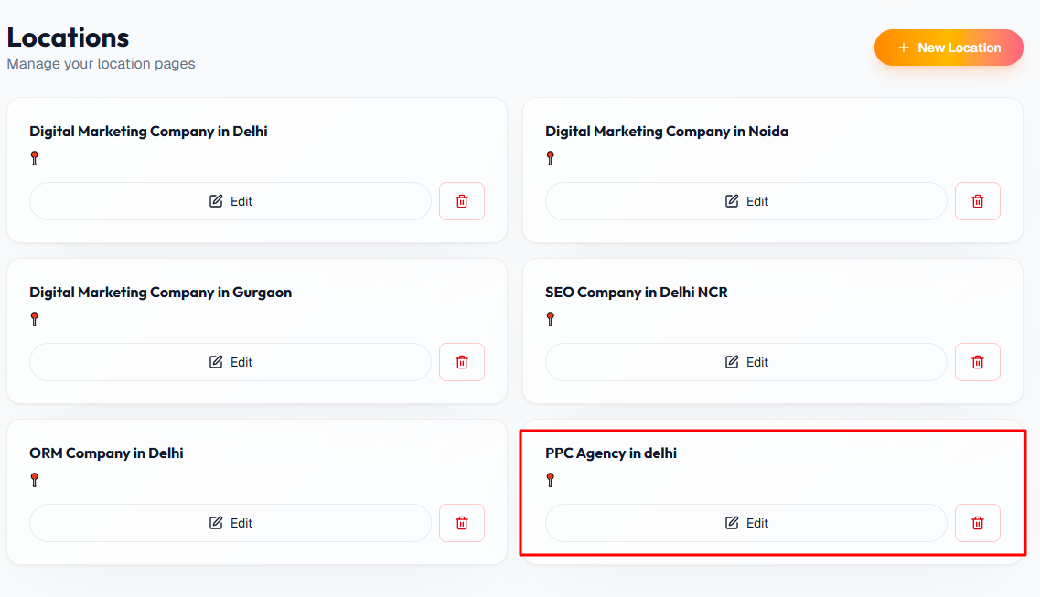

The new page is also not showing in the navigation menu:
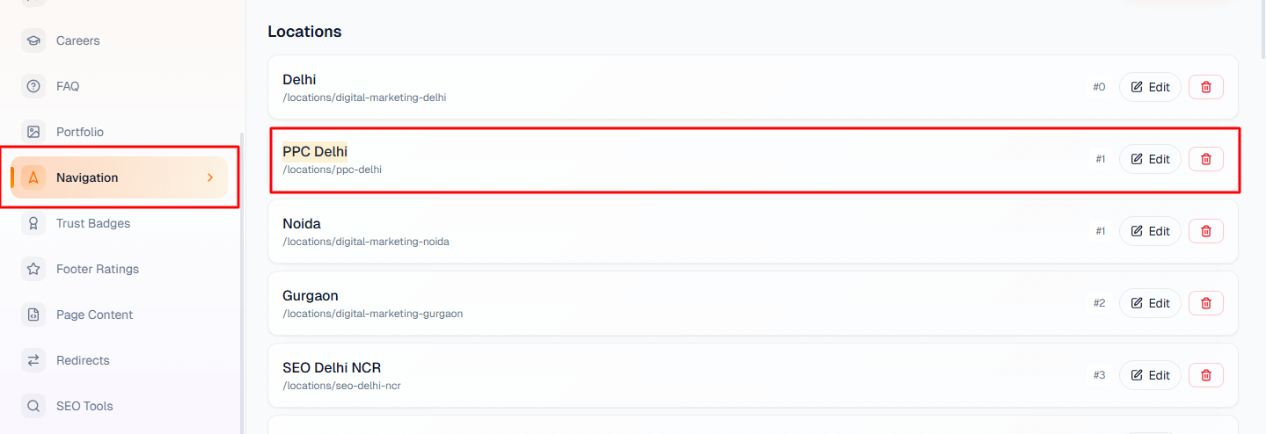

Blogs also not show on the website:
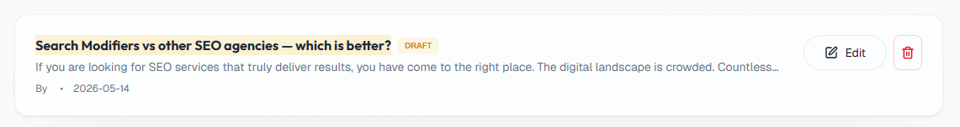
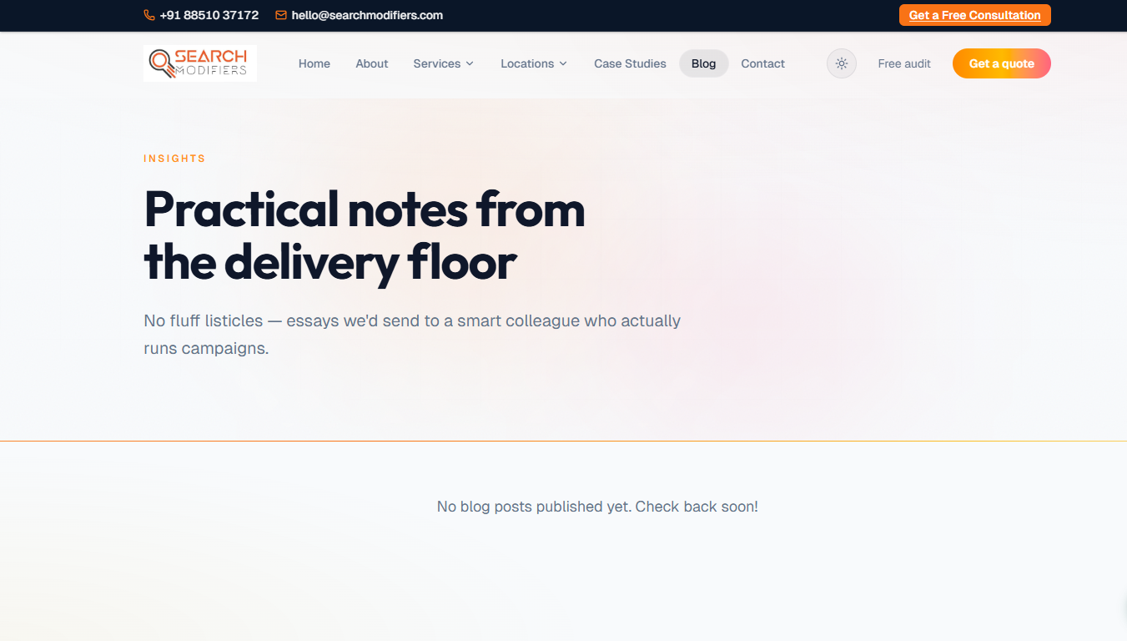

And in the backend, this text is not visible to me on this page: https://www.searchmodifiers.com/services/seo-services
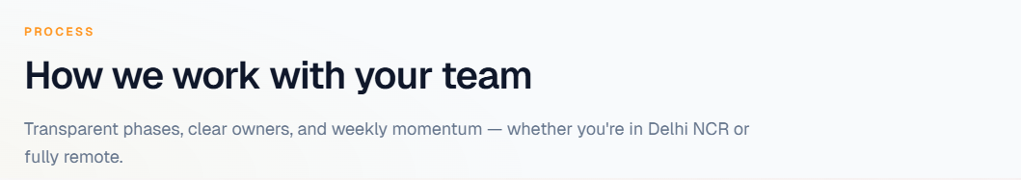

I also added a case study for testing purposes, but it is still not showing live on the website:
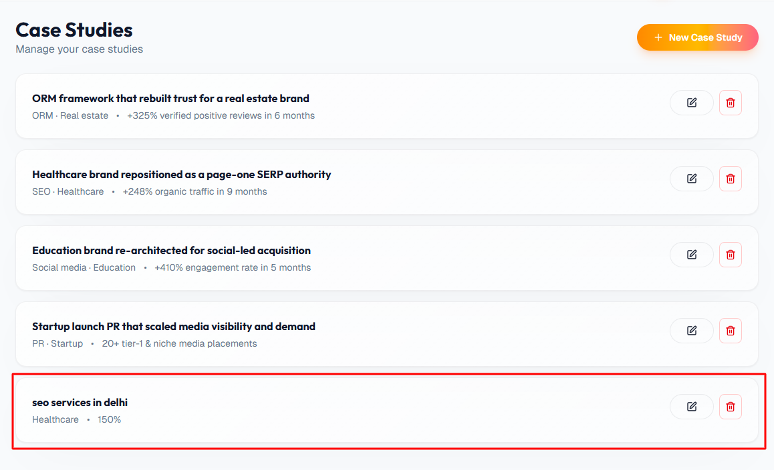

I also added a testimonial for testing purposes, but it is still not showing on the website:

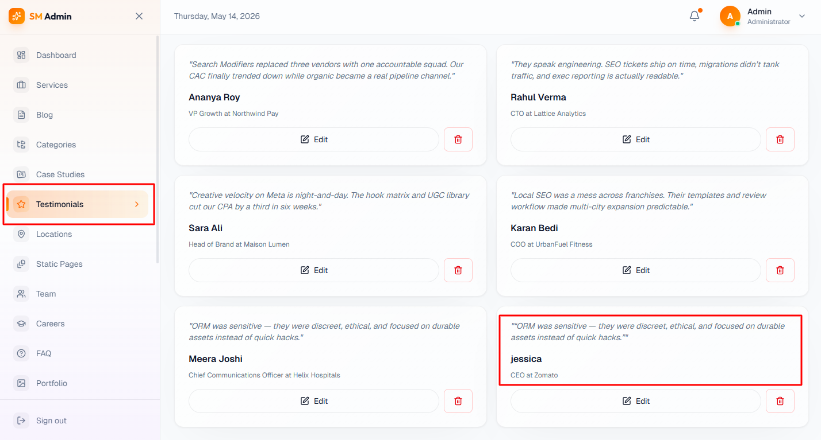

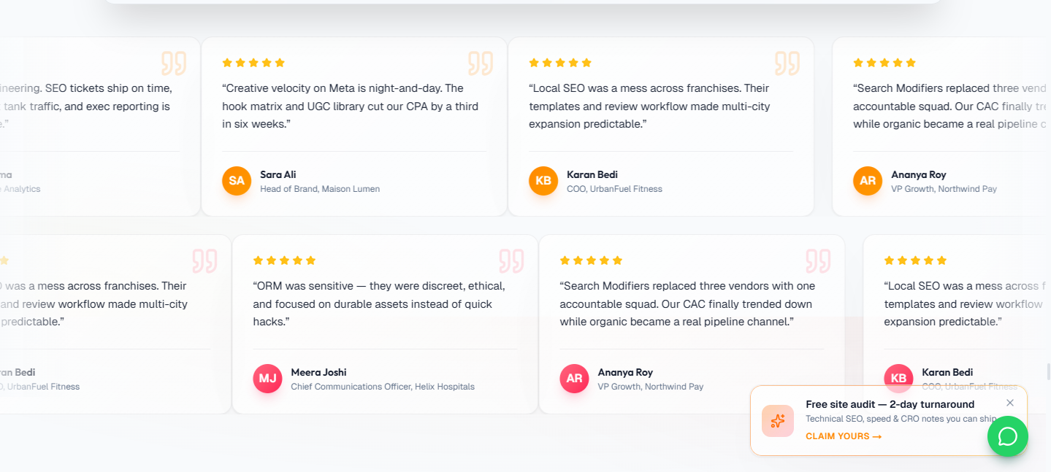

I also added a team member, but that is also not showing on the website:
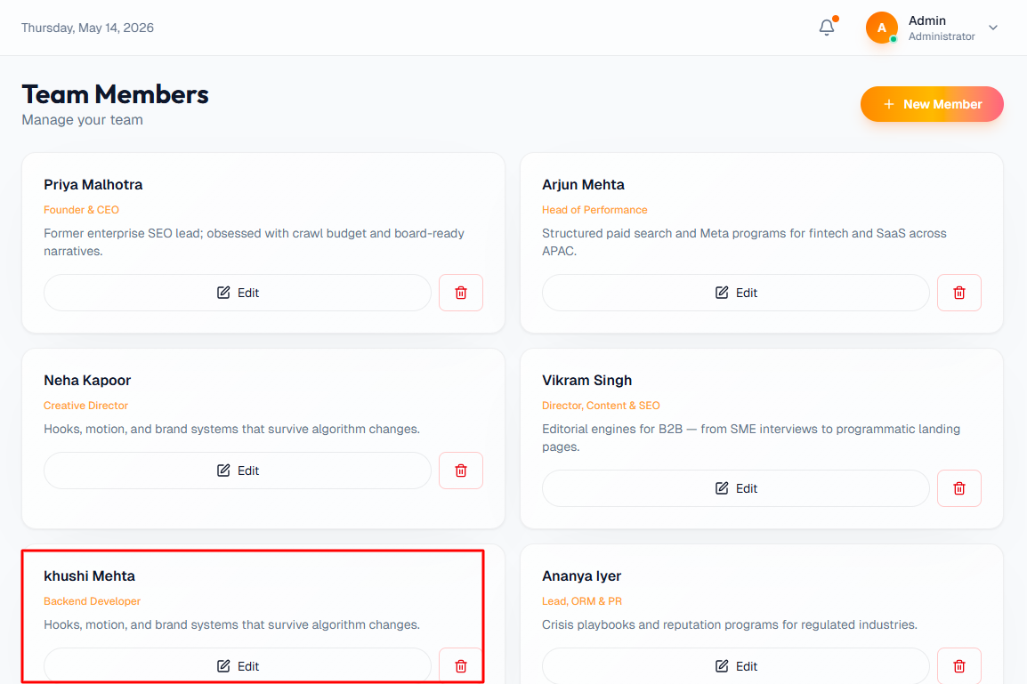
The career role is also not getting added:
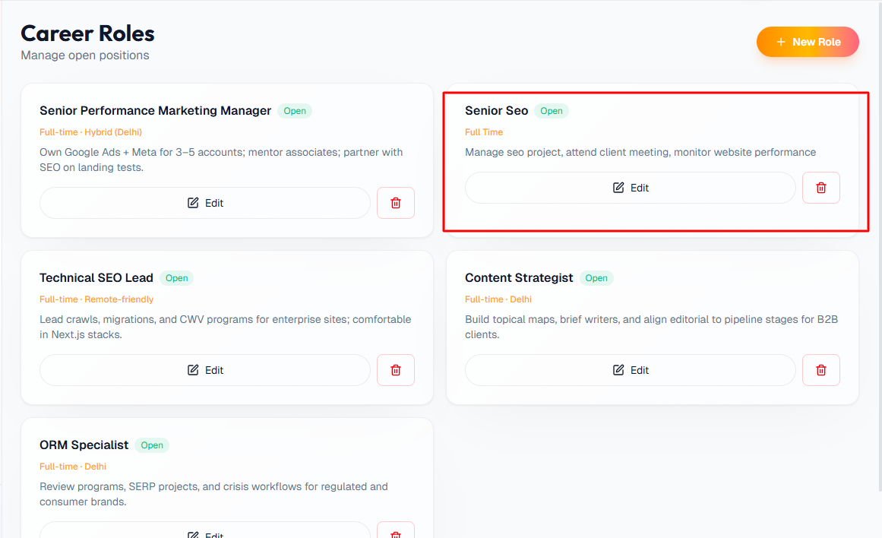

Trust Badges also not updated:
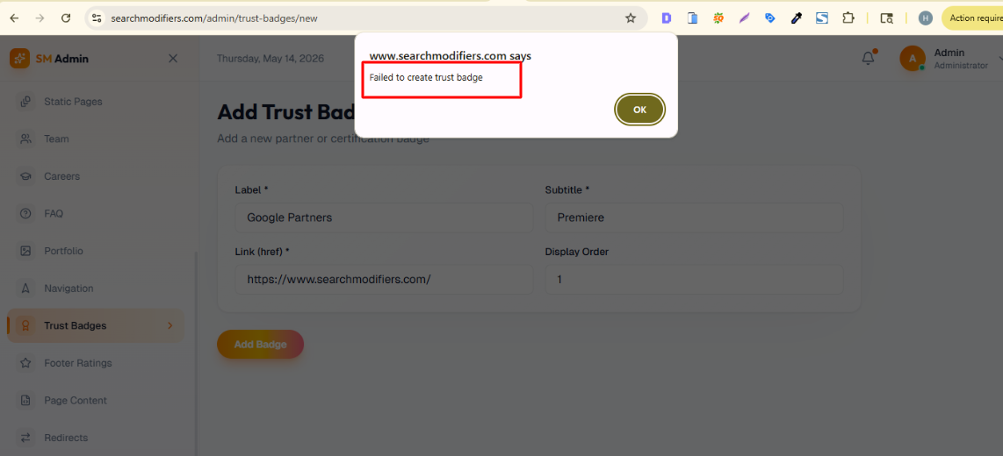

Footer Rating also not updated:
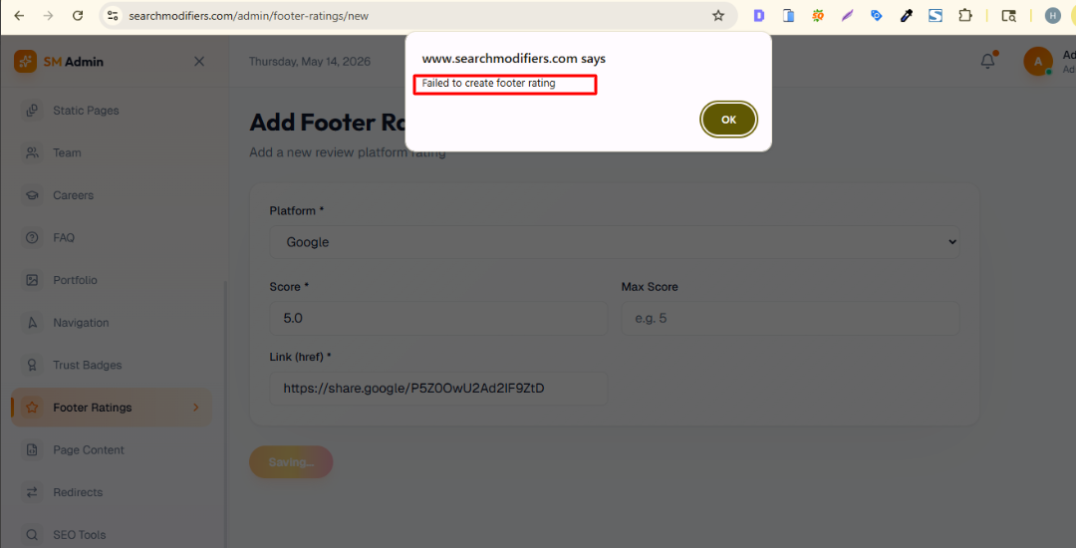

I have created the hero section, but it is not showing on the website:
